**SQL**

**ASSIGNMENT 3**

**Assignment 3 : Retrieve data using Group By clause**

Sample table1: Department

-dept_id

-dept_name

Sample table2: Employee

-emp_id

-dept_id

-mngr_id

-emp_name

-salary

**Create Table --->**

use [Northwind]

go

create table Department(

dept_id int primary key,

dept_name varchar(50),

);

create table Employee (

emp_id int primary key,

dept_id int,

mngr_id int,

emp_name varchar(50),

salary int,

foreign key (dept_id) references Department (dept_id),

);

1. **write a SQL query to find Employees who have the biggest salary in their Department**

SELECT e.DEPT_ID,e.EMP_NAME,MAX(e.salary) MAX_SALARY

FROM employee e

WHERE e.DEPT_ID

IN (SELECT e.DEPT_ID

FROM employee e3 WHERE e.SALARY IN(SELECT MAX(SALARY) FROM EMPLOYEE E2 wHERE e2.DEPT_ID = E.DEPT_ID GROUP BY DEPT_ID)

)GROUP BY e.dept_id,e.EMP_NAME ORDER BY E.DEPT_ID;

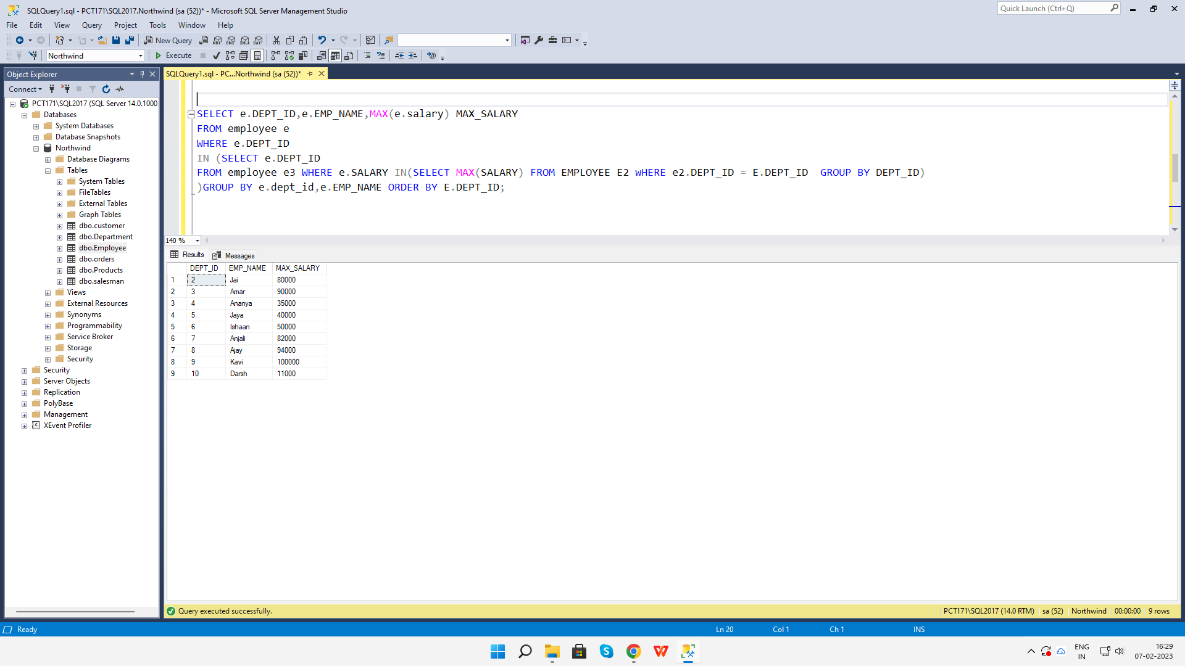

**2. write a SQL query to find Departments that have less than 3 people in it**

select d.dept_id, d.dept_name, count(e.emp_id) employees

from Department d full join Employee e

on d.dept_id = e.dept_id

group by d.dept_id,d.dept_name having count(*) <3

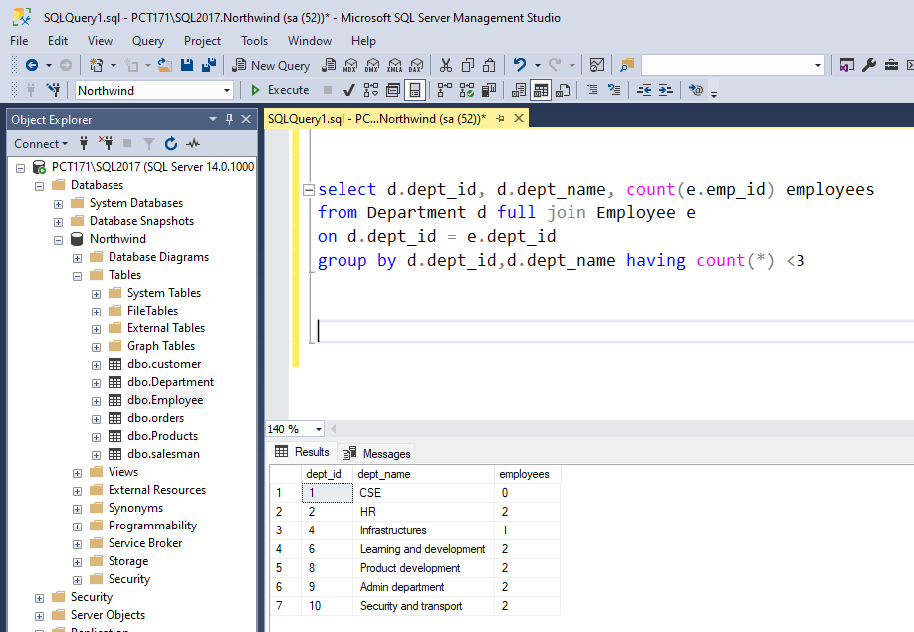

1. **write a SQL query to find All Department along with the number of people there**

select d.dept_id, d.dept_name, count(e.emp_id) employees

from Department d full join Employee e

on d.dept_id = e.dept_id

group by d.dept_id,d.dept_name;

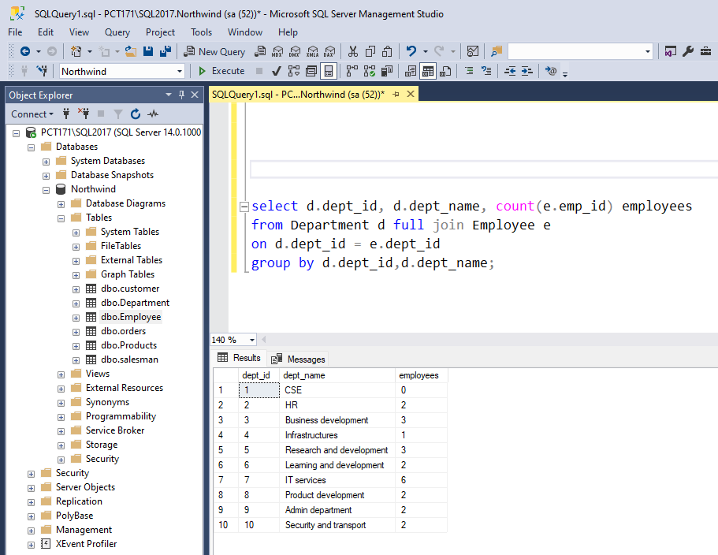

1. **write a SQL query to find All Department along with the total salary there**

select d.dept_id, d.dept_name, isnull(sum(e.salary), 0) Total_salary

from Department d full join Employee e

on d.dept_id = e.dept_id

group by d.dept_id,d.dept_name;

